Multidata base connect in spring boot

Class design for User Entity
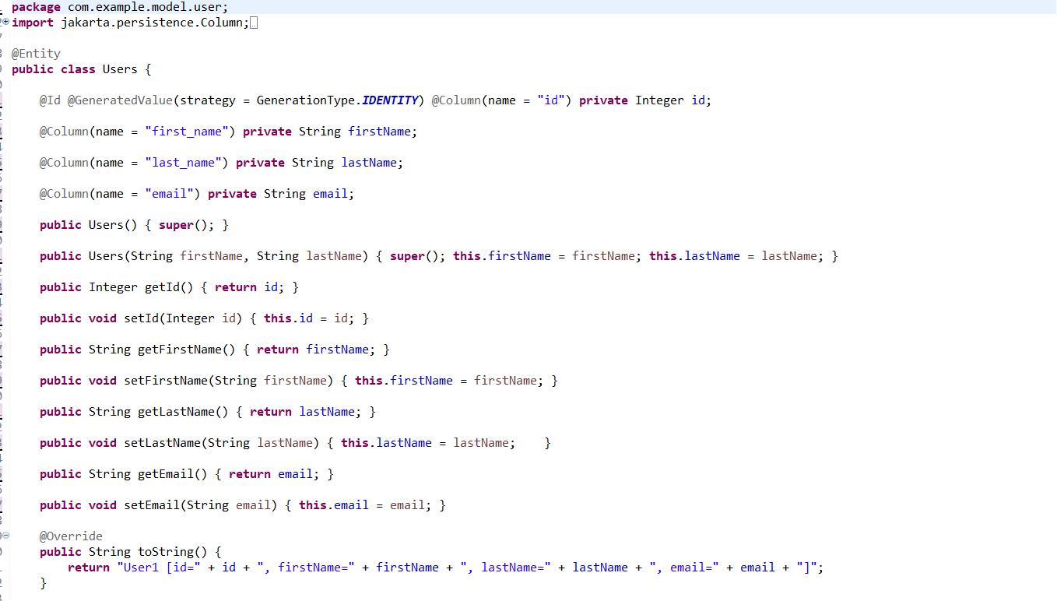

Class design for Order Entity
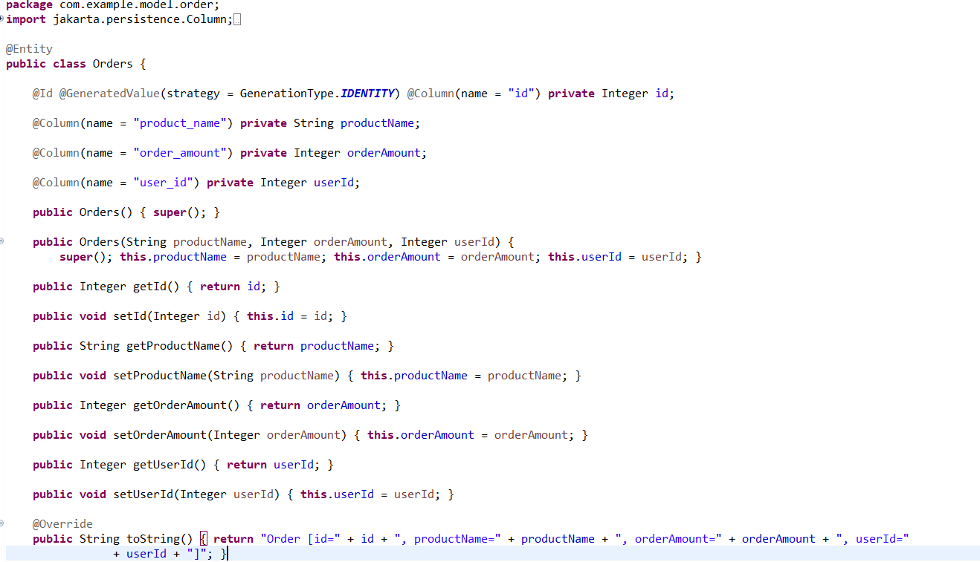

Interface design for Order Repository
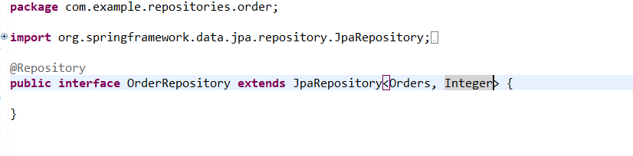
Interface design for User Repository

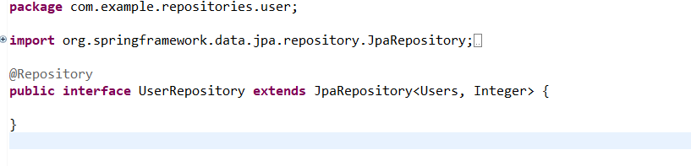
Data source Configuration for User Entity
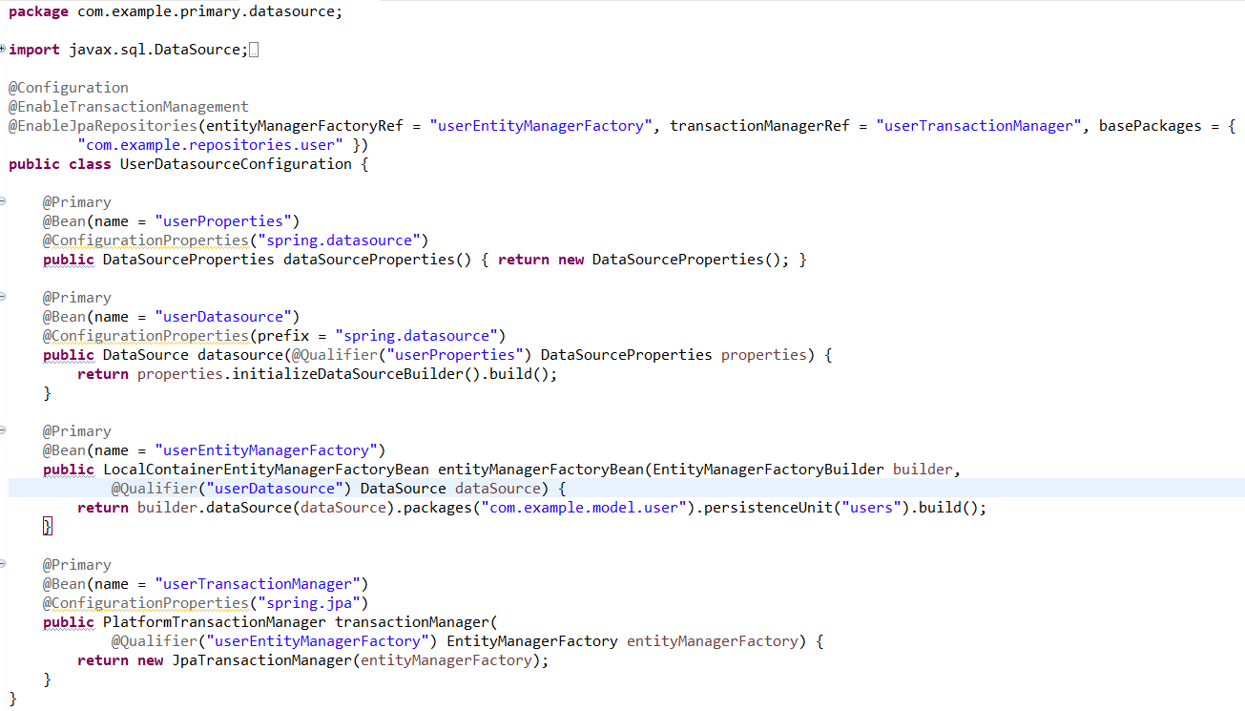

Data source Configuration for Order Entity
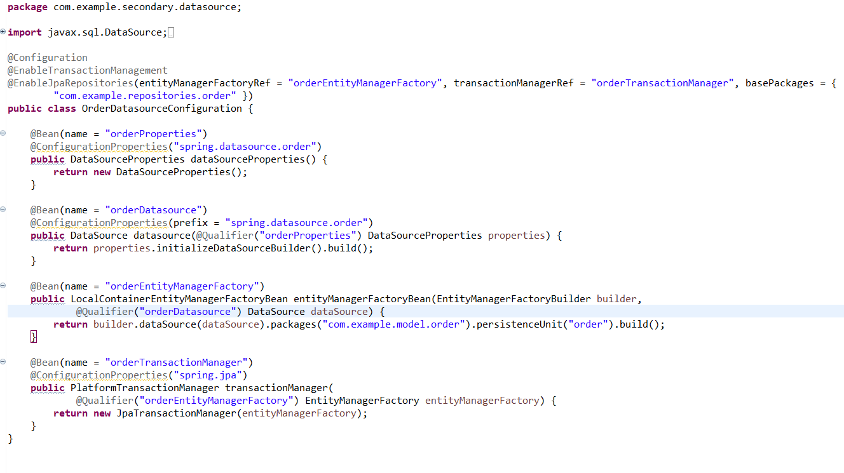
Application property design for configuring two databases
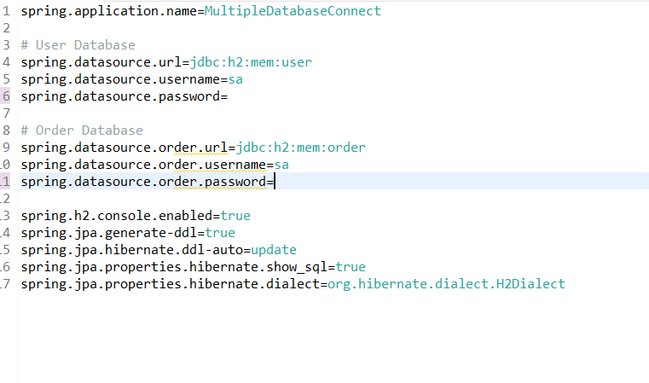

Verify Entity saved entity is retrieved
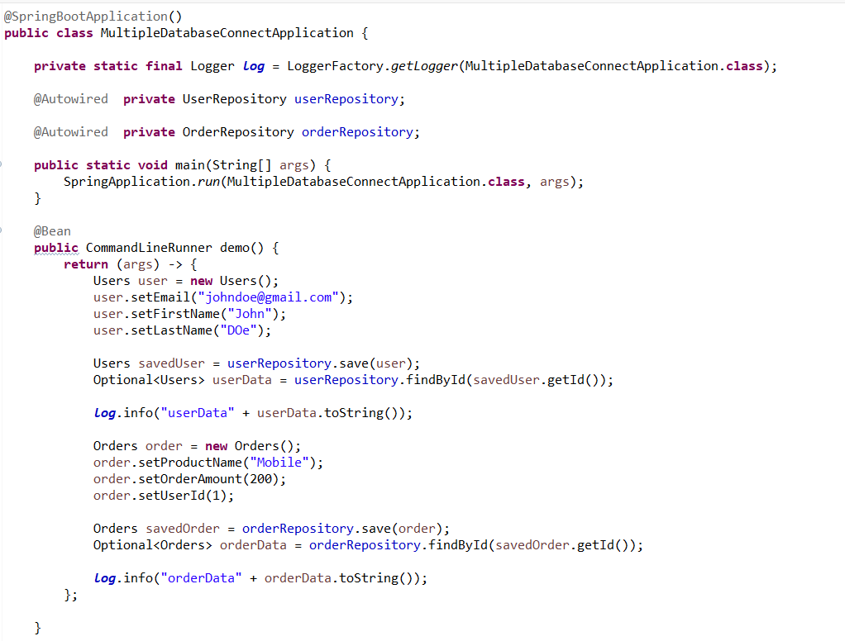

Configuration for pom.xml
